**Experiment 2.1**

**Student Name:** Kusum Singh **UID :** 21BCS10467

**Branch :** CSE **Section/Group :** PH21BCS-908/A

**Semester :** 3rd **Date of Performance:** 09/09/22

**Subject Name :** DBMS **Subject Code :** 21CSH-214

**AIM:** Introduction and implementation of programs using control structures of conditional If-else and case statements.

**S/W Requirement:** Oracle Database 11g Express Edition or Oracle live SQL.

**Objective:**

i.To Learn about if-then statements.

ii.To Learn about if-then-else/elseif statements.

**Practical:**

**Introduction:**

The IF statement executes a sequence of statements depending on the value of a condition. There are three forms of IF statements: IF-THEN, IF-THEN-ELSE, and IF-THEN-ELSIF.

### IF-THEN Statement

The simplest form of IF statement associates a condition with a sequence of statements enclosed by the keywords THEN and END IF (not ENDIF), as follows:

**IF condition THEN**

**sequence_of_statements**

**END IF;**

### IF-THEN-ELSE Statement

The second form of IF statement adds the keyword ELSE followed by an alternative sequence of statements, as follows:

**IF condition THEN**

**sequence_of_statements1**

**ELSE**

**sequence_of_statements2**

**END IF;**

### IF-THEN-ELSIF Statement

Sometimes you want to select an action from several mutually exclusive alternatives. The third form of IF statement uses the keyword ELSIF (not ELSEIF) to introduce additional conditions, as follows:

**IF condition1 THEN**

**sequence_of_statements1**

**ELSIF condition2 THEN**

**sequence_of_statements2**

**ELSE**

**sequence_of_statements3**

**END IF;**

#### **CASE STATEMENT**

The CASE statement in PL/SQL is similar to the IF-ELSEIF condition where different conditions are listed within a block and only that statements get executed for which it satisfies the condition. CASE statement matches the expression value instead of a Boolean expression. The expression could be of any data type and the same data type has to be used in the statements. Each statement has a predefined value and if that value matches up with the values passed in the selector expression then that particular statement gets executed. In this topic, we are going to learn about the CASE statement in PL/SQL.

**Syntax**

Now that you have got a gist of what a CASE statement in PL/SQL is let’s have a look at the syntax of the CASE statement.

**Program Code:**

**1.Write a PL/SQL program to display the description against a grade according to the marks achieved by students in their final exams.**

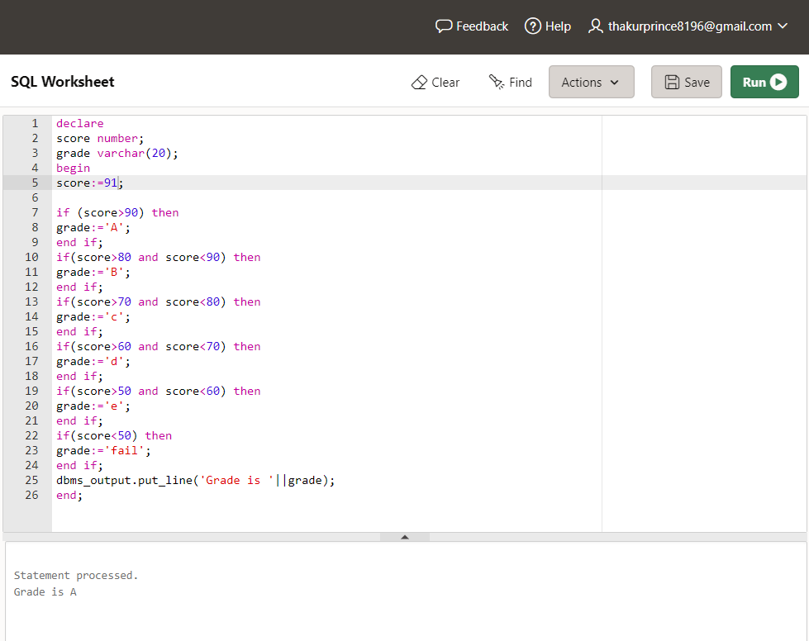

2.Write a PL/SQL program to convert a temperature in scale Fahrenheit to Celsius and vice versa.

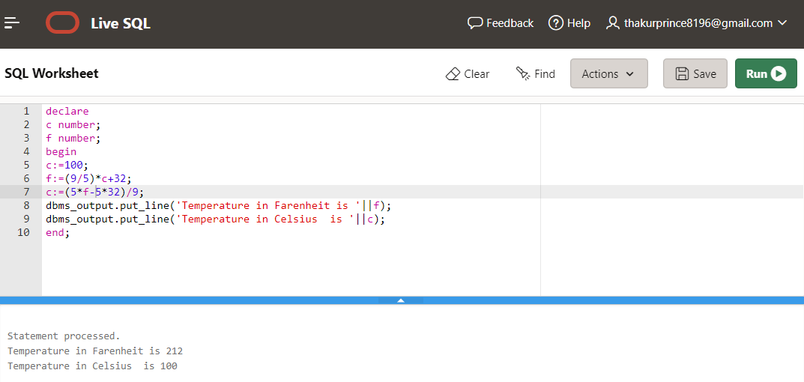

3.**Write a PL/SQL program to check whether a given number is positive, negative or zero.**

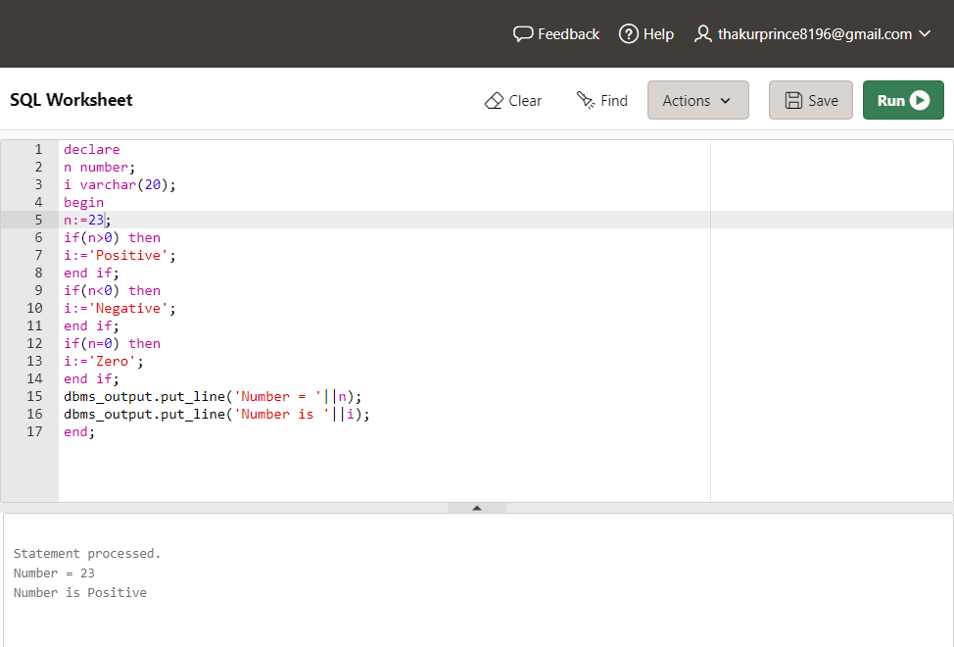

4.Write a PL/SQL program to identify whether a character entered by user is letter or digit.

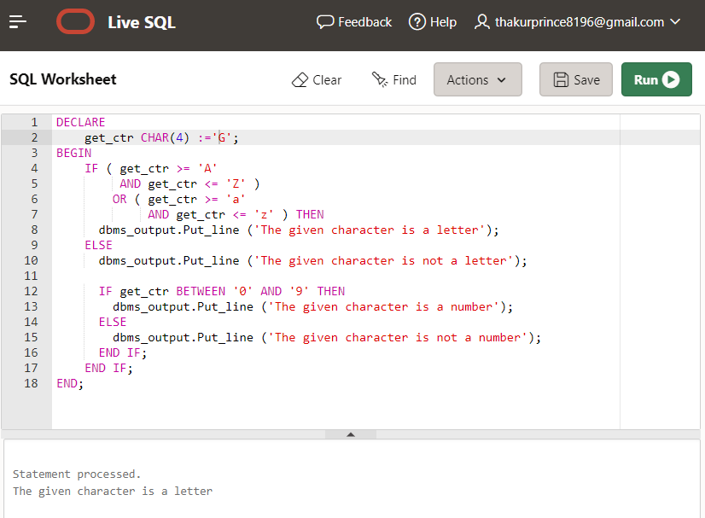

5.Write a PL/SQL program to check whether a date falls on weekend i.e. SATURDAY or SUNDAY.

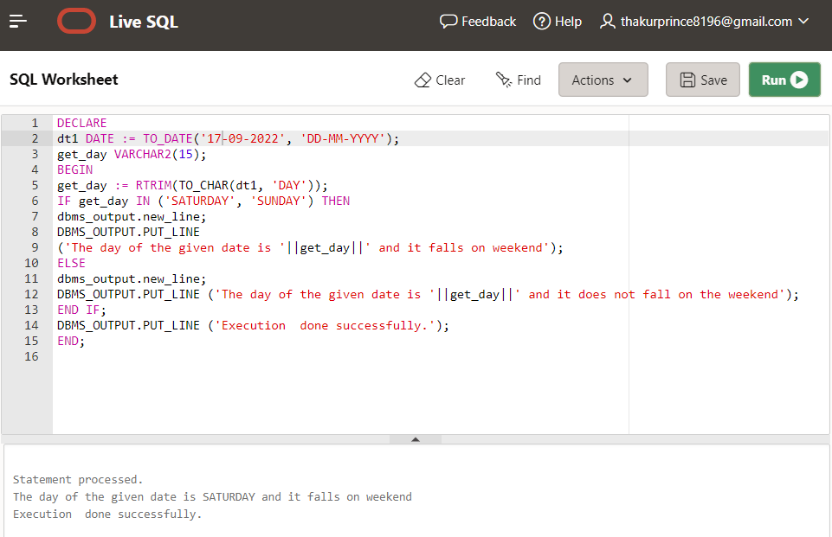

# Learning outcomes (What I have learnt):

* 1. Learnt the concept of PL/SQL.
  2. Learnt if-then statements.
  3. Learnt Syntax of if-then-else statements.

# Evaluation Grid :

|  |  |  |  |
| --- | --- | --- | --- |
| **Sr. No.** | **Parameters** | **Marks Obtained** | **Maximum Marks** |
| **1.** | **Student Performance (Conduct of experiment) objectives/Outcomes.** |  | **12** |
| **2.** | **Viva Voce** |  | **10** |
| **3.** | **Submission of Work Sheet (Record)** |  | **8** |
|  | **Total** |  | **30** |